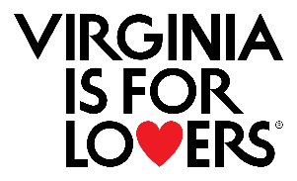
Virginia Tourism Corporation
Microbusiness Marketing Leverage Program (MMLP)
Application Template

Applicants must attest to the terms and conditions at the time of application. For information on how to apply to this program, please refer to the Summer 2026 Microbusiness Marketing Leverage Program instructions, sample application, and webinar recording.

This document is intended to serve as a template to assist you in drafting your application. It is not the official application and should not be submitted as such. Applicants are required to complete and submit the official application through vatc.org.
There are character limits on each question. A maximum of 1,000 characters are permitted.

MMLP Grant Application Window: June 23, 2026 | 9:00 a.m. ET – July 30, 2026 5:00 p.m. ET
Extensions: The MMLP program is not eligible for project extensions.
Max Award: $5,000
Match Required: 1:1 cash or in-kind match
Eligible Expense Period: May 1, 2026 – May 31, 2027

Applicant Acknowledgement
Before you can continue to the application, please acknowledge the following (Click the checkmark and it will turn blue):
I understand that this is a competitive program and a funding award is not guaranteed and I understand that my requested award may be reduced or denied based on available funding.*
- I agree.
I understand this is a 1:1 match program and that match can be in-kind or cash and no funds will be granted up front.*
- I agree.
I understand that this program is for eligible expenses incurred between May 1, 2026 to May 31, 2027, focused on driving fall/winter/spring visitation, and that my reimbursement requests must be submitted no later than by July 31, 2027.*
- I agree.

Program Information
Applicant Business/Organization Name (This must be the same as listed on your EIN and W-9)*:
EIN # (only one application permitted per EIN #)*:
Application Organization Street Address*:
Street Address:
Address Line 2:
City:
State:
Zip Code:
Applicant Locality*
If a town or DMO, please select the county where the town is located:

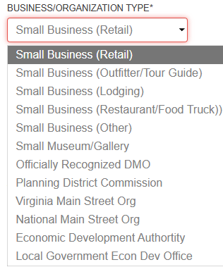
Business Organization Type*

How many full-time employees do you have?*

How many part-time employees do you have?*

Amount of requested funds (Max Award $5,000) Use whole numbers only.
Please refer to the maximum award for your attendance in the program Terms and Conditions. Requested funds must equal the total of reimbursable marketing plan found in step 5 of application.:

Applicant Contact Information
Applicant Organization Primary Contact Name*
First:
Last:
Applicant Organization Secondary Contact Name*
First:
Last:
Contact Email:
Contact Phone Number*:
Secondary Contact Email:
Secondary Contact Phone Number*:
Contact Mailing Address*:
Street Address:
Address Line 2:
City:
State/Province/Region:
Zip/Postal Code:

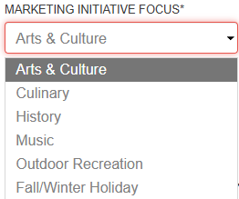
Marketing Initiative Focus*:

Marketing Initiative Name*:

Goals & Partnerships (25 Points)
What do you want to accomplish with your requested funds? (This should be measurable.)*:

Performance Measure #1*:
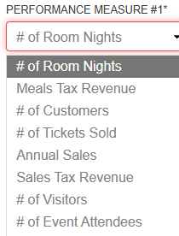

Performance Baseline #1 (Now)*:
Performance Goal (May 2027)*:

Performance Measure #2*:

Performance Baseline #2 (Now)*
Performance Goal (May 2027)*

Hub & Spoke Itinerary
Please refer to application instructions to understand VTC Hub & Spoke Model.
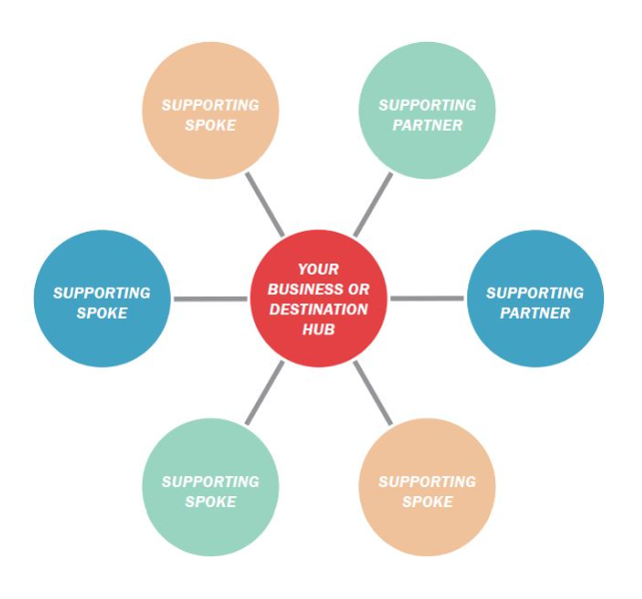

Loding Partner*:
If the applicant is the lodging partner, please put the name of your property.
Partner #2:
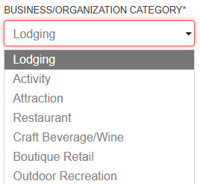
Business/Organization Category*:

Spoke #3:
Business/Organization Category*:

Spoke #4:
Business/Organization Category*:

Spoke #5:
Business/Organization Category*:

Spoke #6:
Business/Organization Category*:

How will you and your partners work together to achieve your goals?*

What marketing message will help you and your partners achieve your visitation/visitor spending goals? Think about how you will motivate travelers to come to your business, events, or destination.*

Research/Data (25 Points)
What research/data did you use to set your goals?*

What research/data did you use to develop your marketing message?*

Target Markets
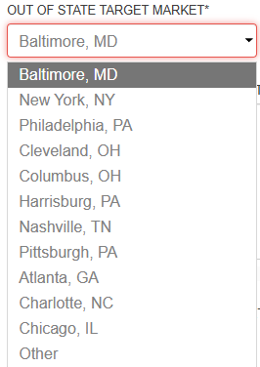
Out of State Target Market*:

What research/data are you using to choose this target market?*

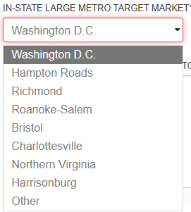
In-State Large Metro Target Market*:

What research/data are you using to choose this target market?*

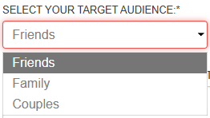
Select your Target Audience*:

What research/data are you using to choose this target audience?*

Marketing Plans (50 Points)
AS A REMINDER, please refer to the terms and conditions and program instructions to correctly complete the following marketing plans.
In-Kind or Cash Match Marketing Plan*
In-Kind Marketing Plan (This is your match. This grant requires a 1:1 match. Be sure to read instructions on eligible items, how to value followers, and how to value earned media like magazine articles.) Max 10 lines. Use (+) to add lines to your in-kind marketing plan.
Match Type (paid, earned, or owned media:
Media Name:
Description of media type, demographics, target market:
Publish, placement and count date *required*:
Amount/Value:
Total in-kind marketing plan:

VTC Reimbursable Marketing Plan*
Reimbursable Marketing Plan (This is what you would like be reimbursed by VTC. Be sure to review the eligible expenses list. Ineligible items will not be reimbursed.) For Media Type, please select from the following: Instagram, Facebook Google Ads, Blue Ridge Outdoors, Leisure Digital Trip Advisor, Welcome Centers/PMAP, Other (Print), Other (Digital), or Other (Services). Max 10 lines

Media Name:
Description of media type, demographics, target market:
Publish/placement and dates *required*:
Amount:
Total reimbursable marketing plan:

Bonus Points: VIFL Activation Type (5 Bonus Points)
How will you integrate the Virginia is for Lovers brand in your marketing and advertising materials? (Select from Drop Down Box)
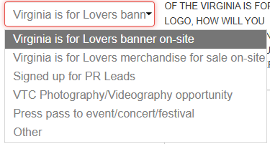
- VIFL Activation Type:

Beyond the required usage of the Virginia is for Lovers logo, how will you integrate the Virginia is for Lovers brand in your marketing and advertising materials?:

Dates (If Applicable):

- VIFL Activation Type:

Beyond the required usage of the Virginia is for Lovers logo, how will you integrate the Virginia is for Lovers brand in your marketing and advertising materials?:

Dates (If Applicable):

- VIFL Activation Type:

Beyond the required usage of the Virginia is for Lovers logo, how will you integrate the Virginia is for Lovers brand in your marketing and advertising materials?:

Dates (If Applicable):

- VIFL Activation Type:

Beyond the required usage of the Virginia is for Lovers logo, how will you integrate the Virginia is for Lovers brand in your marketing and advertising materials?:

Dates (If Applicable):

- VIFL Activation Type:

Beyond the required usage of the Virginia is for Lovers logo, how will you integrate the Virginia is for Lovers brand in your marketing and advertising materials?:

Dates (If Applicable):

Please upload a letter of support from the local or regional DMO. If there is not a DMO that support the event location, please upload a letter of support from the locality.*
You can find your DMO contact information at https://vatc.org/dmolistpdf. Please allow your DMO ample lead time to provide the letter of support. If the applicant is the DMO, please upload a letter to that effect.
Upload Signed Letter of Support from Destination Marketing Organization (DMO)
Upload Signed Letter of Support from Lodging Partner

Save & Submit
VERY IMPORTANT:
- Your application information is saved on our server as you enter it.
- If you need to leave the application, scroll to the bottom of the application and click “Save and Continue Later”.
- You will receive a unique URL that will allow you to go back into the application to make edits. BE SURE TO COPY THIS URL SO THAT YOU CAN GO BACK TO EDIT YOUR APPLICATION!
- You also can enter your email address and have the link sent to you.
- You will need to follow this procedure each time you leave the application in order to save your work.

Once you are ready to submit the Final Version, you will acknowledge the Acceptance of Terms.
- A SUBMIT button will appear
- At that point you may submit your application.
- Please note that once you submit, you will NOT be able to make any revisions to your application.
- If you do not receive a confirmation email within 15 minutes, please reach out to us.

DEADLINE INFORMATION:
- Applications are due by 5:00 PM on Thursday, July 30, 2026.
- NO extensions to this deadline will be possible.
- Award announcements will be made October 2026.

Acceptance of Terms*
 I understand that by submitting this application that I am agreeing to the full program Terms and Conditions.

Submission Confirmation*
I understand that my application is not fully submitted until I see the final submission screen and receive a .pdf of my application in my inbox (usually within 15 minutes.) I will contact VTC at vtcmlpgrant@virginia.org within 24 hours if I do not receive the pdf of my application in my email inbox.

