VTC 2026 DMO Marketing Program Application
Fillable Template (Copy & paste answers into the application portal.)

Applicant Acknowledgment
Please review each statement carefully and check each box to indicate your agreement.
☐ I understand this is a reimbursement program and no funds will be granted up front.
☐ I understand I must use the Virginia is for Lovers logo and submit proof of marketing and payment.
☐ I understand this funding is for new marketing initiatives only.
☐ I understand eligible expenses and reporting requirements.

Program Information
Provide legal and organizational information as it should appear in official records.
DMO Name
____________________________________________
EIN #
____________________________________________
Street Address
____________________________________________
Town Name (if applicable)
____________________________________________
Locality
____________________________________________
GO Virginia Region #
Lookup: www.dhcd.virginia.gov
____________________________________________
House of Delegates District #
Lookup: www.whosmy.virginiageneralassembly.gov
____________________________________________
State Senate District #
____________________________________________
U.S. House of Representatives Congressional District #
____________________________________________
Business/Organization Type
____________________________________________
Number of Full-Time Employees
____________________________________________
Number of Part-Time Employees
____________________________________________
What is your DMO’s annual operating budget?
_____________________________________________
Does any of your budget or matching funds come from a Tourism Investment District (TID)?
Yes or No
Amount of Requested Funds
Requested funds must be equal to total of reimbursable marketing plan
____________________________________________

Applicant Contact Information
This should be the primary contact responsible for this application.
Contact Name
____________________________________________
Email Address
____________________________________________
Phone Number
____________________________________________
Mailing Address
____________________________________________

Marketing Initiative
Marketing Initiative Focus
Drop Down Box Choices
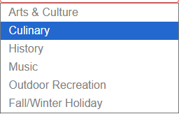
____________________________________________
Marketing Initiative Name
Please do not use the same name as applicant name. Be creative.
____________________________________________
Program Start Date (Not before 12/01/2025)
____________________________________________
Program End Date (Not after 10/31/2027)
Reminder: Final reimbursements are due not later than 60 days after your program end date.
____________________________________________

Goals and Partnerships (25 Points)
Responses should be specific, measurable, and clearly aligned with proposed marketing activities.
What do you want to accomplish with the requested funds?
Describe goals, outcomes, and success metrics. Quantify when possible.

__________________________________________________________________________

How will you measure your progress?
Describe goals, outcomes, and success metrics. Quantify when possible.

_________________________________________________________________________

Performance Outcomes
List measurable performance indicators with current baselines and projected targets.
Performance Outcomes Drop Down Box Choices
Select Two and only metrics that you can track.
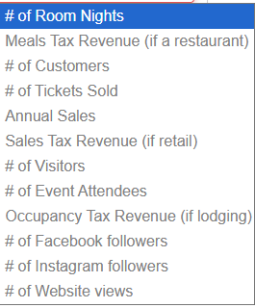
Metric | Baseline (Now) | Target (Program End Date)
Select from Drop Down
Select from Drop Down

Hub & Spoke Itinerary
Identify all partners and spokes involved and describe their role in this initiative. Create a hub and spoke of partners who are working together on this marketing initiative. These must be tourism-oriented businesses.
Business Category Drop Down Box Choices for Hub & Spoke

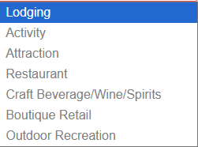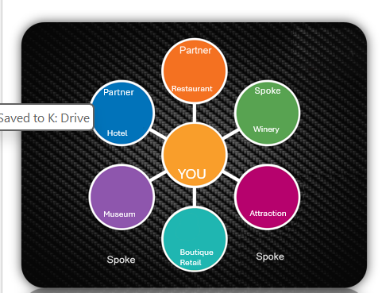

Identify all partners and spokes involved and describe their role in this initiative. Partner #1 Must be a lodging partner. Use names of businesses and then select the category from the drop-down box.
Partner / Spoke Name | Business Category
Partner #1 | Select from Drop Down Box
Partner #2
Spoke
Spoke
Spoke
Spoke

How will you and your partners work together to achieve your goals?
Explain coordination, cross-promotion, and shared responsibilities. Please list exactly what each partner and spoke is doing to support this marketing initiative.

___________________________________________________________________________

What marketing message will help achieve visitation and spending goals?
Describe the primary message and how it motivates travel or spending. Think about how you will motivate travelers to come to your business, events, or destination.

_______________________________________________________________________________

Research and Data (25 Points)
Cite specific data sources and clearly connect insights to strategy.
What research/data did you use to set your goals? What did the research tell you?
Identify sources (e.g., Arrivalist, Longwoods, Census, web analytics) and summarize findings.
_________________________________________________________________________________

What research/data did you use to develop your marketing message? What did the research tell you?
Identify sources (e.g., Arrivalist, Longwoods, Census, web analytics) and summarize findings.
___________________________________________________________________________________

Out-of-State Target Market and supporting research
Select ONE out-of-state target market from drop down box
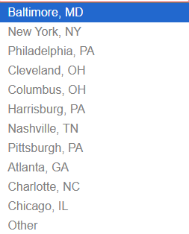
What research/data are you using to choose this target market? What did the data tell you?
Identify sources (e.g., Arrivalist, Longwoods, Census, web analytics) and summarize findings.
________________________________________________________________

In-State Target Market and supporting research
Select ONE in-state target market from drop down box
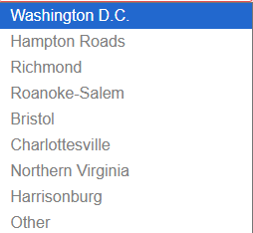

What research/data are you using to choose this target market? What did the research tell you?
Identify sources (e.g., Arrivalist, Longwoods, Census, web analytics) and summarize findings.

________________________________________________________________________________

Target Audience research used
Select target audience from drop down box
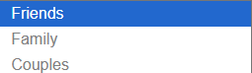

Looking at vatc.org/research, tell us what research you used to identify your target audience.
Identify sources (e.g., Arrivalist, Longwoods, Census, web analytics) and summarize findings.
____________________________________________________________________________________
Please tell us about any additional research you are using.
____________________________________________________________________________________

Marketing Plans (50 Points)
All expenses must align with program eligibility requirements.
In-Kind Cash Match Marketing Plan (This is your match. This grant requires a 50% in-kind or cash match. For Media Type, please select from the following: Social, Digital, Print, Agency, Influencer, Website, Radio, TV or Other Services. DO NOT put Vendor name in your Marketing Plan. Please no commas or dollar signs in your marketing plan amounts and please tab through the fields for totals. Max 15 lines. Use (+) to add lines to your marketing plan.
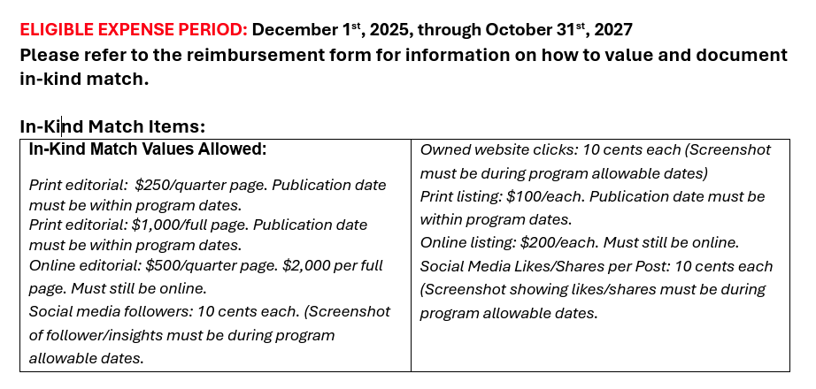

In Kind or Cash Match Marketing Plan
List all cash match marketing activities. Amounts should equal total cash match.
Media Type & Description | Target Market/Demographic | Ad Placement Dates | Amount ($)
Total Cash Match: ____________________ please double check your totals. Tab through all the columns.

VTC Reimbursable Marketing Plan
List only expenses requested for reimbursement from VTC.
Reimbursable Marketing Plan (This is what you would like be reimbursed by VTC. Be sure to review the eligible expenses list. Ineligible items will not be reimbursed.) For Media Type, please select from the following: Social, Digital, Print, Agency, Influencer, Website, Radio, TV or Other Services. Please no commas or dollar signs in your marketing plan amounts and please tab through the fields for totals Max 15 lines.
Media Type & Description | Target Market/Demographic | Ad Placement Dates | Amount ($)
Total Reimbursable Amount: ____________________ please double check your totals. Tab through all the columns.

BONUS POINTS: VIFL Activation (5 Points)
Describe how Virginia is for Lovers branding and VTC services will be incorporated. Be creative.
How will you integrate the Virginia is for Lovers brand and VTC services/opportunities?
Attach Lodging Letter of Support (required)
Attach additional documents (optional)

