**Virginia Tourism Corporation Summer 2024**

**Special Events & Festivals Sponsorship**

**Program Instructions**

**Application must be submitted in VTC’s online application portal.**

**Please do not use colons, semicolons, or ampersands in your narrative since these characters cause coding issues in the portal.**

**Program Opens: July 16, 2024 at 9 a.m.**

**Program Closes: September 26, 2024 at 5 p.m.**

**(No Late Applications Accepted)**

Please note that the application has changed substantially from the 2023 grant round.

Funding available in this grant program: **$800,000**

# of proposals to be funded this round: **60**

Award Notification Date: **November 2024**

Application Window: **July 16, 9:00AM – September 26, 5:00PM (NO EXTENSIONS)**

**\*\*\*THIS ROUND OF THE VTC SPECIAL EVENTS AND FESTIVALS PROGRAMS IS ONLY FOR EVENTS THAT OCCUR BETWEEN JANUARY 1, 2025, THROUGH DECEMBER 31, 2025. \*\*\***

**\*\*\*There will NOT be a round of the Special Events and Festivals Sponsorship Program opening in February 2025. The next round will open in July 2025 for Calendar Year 2026 events.\*\*\***

**Three Award Tiers**

* **Tier 1 - $5,000: For special events and festivals with 500 - 4,999 attendees**
* **Tier 2 -$10,000: For special events and festivals with 5,000 – 19,000 attendees**
* **Tier 3 - $20,000: For special events and festivals with 20,000 or more attendees**

**Attendance is calculated based on the cumulative total across all days of the event/festival.**

**Virtual attendees cannot be counted in your cumulative attendance.**

**Purpose:** The program is to drive visitation to Virginia through special events and festivals. Applications must show positive and significant economic impact. Funds should not be used to support basic operating expenses, but should be used to target new audiences, expand the festival footprint, or improve and marketing visitor experiences at the special event or festival.

**Please continue to the next page to view the application screenshots, questions, and helpful information about how to fill out the application in the online portal.**

**Applicant Acknowledgment Section:**

*Applicants must check the boxes acknowledging they understand the programs rules, terms and conditions*.

*Please be sure that the checkmarks turn blue as you check them off in the online application portal.*

*Once you complete the checkbox acknowledgements, click “Continue to Event Information” to continue to the next section.*

*If the screen does not move on to the next section, it means that something is incomplete. If this happens, double check your responses, checkmarks, attachments, etc.*

**Event Info & Contact Information Section:**

**Applicant Organization Name:**

**EIN#/SSN:**

**Applicant Street Address:**

**City, State, Zip:**

**Event Name**:

**Start date & end date.**

*Events must be AT LEAST TWO CONSECUTIVE DAYS to qualify for this program. For more information on this requirement, please refer to the program FAQs.*

**Prior Year Attendance #1:**

**Prior Year Attendance #2:**

*Please indicate your prior two years of attendance. While you may apply for the award tier based on your 2025 projected attendance, we will use your prior two years of attendance for fidelity of your 2025 projected attendance.*

***Events that are held during the latter half of 2024 and are in their second year may project their 2024 attendance in order to apply in this round****.*

**Please upload proof of attendance.**

*This can be ticketing reports from ticketing software or venue software such as Ticketmaster. It can be screenshots of Facebook RSVPs, Eventbrite reports, etc. If no reports are available, a letter signed by the event organizer attesting to the prior two years of event attendance will be accepted*

**Please upload proof of general liability insurance** *with VTC listed as an interested party. If not available at time of application, VTC will send a reminder to submit this BEFORE your event.*

**Select locality where event will be held from the drop down list. If a town, select the county. This is critical information for our GO Virginia regional calculations.**

**Amount of Requested Funds:**

*This should be equal to the sum of your reimbursable marketing plan and reimbursable production plan.*

**Contact Name:**

**Email:**

**Phone:**

**Address:**

**City, State, Zip:**

**Select the Event Type from the drop-down box.**

**Upload a letter of support from the local or regional DMO.** *You can find a list of DMOs at* [*www.vatc.org/dmolist*](http://www.vatc.org/dmolist)*. If there is no DMO covering your locality, you may upload a letter of support from a locality leader such as town manager, county manager, county supervisor, etc.*

**Indicate whether your event/business/destination is listed on Virginia.org** and **include the url where requested**. *While the listing isn’t required to apply, you must have your listing completed before you seek reimbursement.*

*You can create an account and listing here:* [*https://www.vatc.org/marketing/digital-marketing/webmarketing/*](https://www.vatc.org/marketing/digital-marketing/webmarketing/)

*This is a multi-step process and can not be completed in one day.*

**Click “Continue to Goals and Partnerships”**

**Goals & Partnerships Section:**

**This section is worth 25 points.**

**Describe the visitor experiences at your special event or festival for each day.**

*Example below:*

*July 7, 2025—VIP ticketed dinner and autograph session with performers.*

*July 8, 2025—Two stages, tentative line up is Bon Jovi, U2, The Cure. Artisan Market and Food Truck Rodeo. Festival hours are 12noon to 10pm. We expect 40 artisan booths and 18 food trucks.*

*July 9, 2025—Three stages, tentative line up is…*

*List by date what is happening at your event or festival. Tell us the number of stages, performers (even it not yet contracted), concessions, vendors, other programs, and any other things the visitor can do.*

**What do you want to accomplish with your requested funds?**

*Tell us what you want to accomplish with the requested funds. Will you add a second stage, target a new marketing, target new demographics, rent a larger parking area, create new marketing collateral with your partners, do a robust social media marketing push? Be sure your goals align ability to outcomes.*

**Select two performance outcomes that you can track and that align with your program goals.** *Give a baseline number as of the date of application and then give a goal you will strive to achieve for your 2025 event.*

**The Hub and Spoke is VTC itinerary building tool and is designed to help you build tourism partnerships in your destination.** *Imagine your business, destination, or attraction as the hub. And then identify a lodging partner, another tourism partner, and two tourism-oriented spokes that will work with you to achieve your goals.* ***Media vendors and event sponsors are not eligible to be partners or spokes.*** ***Partners and spokes must be tourism-oriented businesses such as attractions, lodging, outfitters, tours, and/or restaurants.***

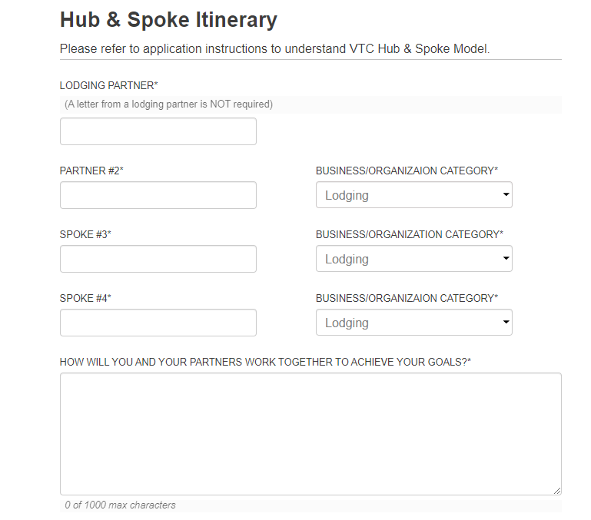

**Be sure to use the drop down box and identify the category of your partners and spokes.** *One lodging partner is required. However, you may select additional lodging partners.*

**How will you and your partners work together to achieve your goals?**

*In this section, tell us how you are all working together. Are you creating lodging packages, cross-promoting each other, pooling marketing funds to do more robust marketing, etc.*

*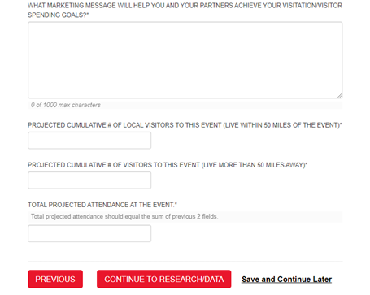***What marketing message will help you achieve your visitation goals? How will you motivate travelers to visit?**

*Think through what message, images, videos, taglines, etc. that will motivate your target market/demographic to visit your event. How will you convince your target market/demographic to go to your special event or festival.*

**Then project the attendees to your 2025 event dividing them into two categories:**

**Number of attendees who live within 50 miles of the event/festival:**

**Number of attendees who live more than 50 miles away from the event/festival:**

*Please calculate these numbers to the best of your ability and with fidelity for our economic impact evaluation.*

**Click “Continue to the Research/Data”**

**Research & Data Section.**

**This section is worth 25 points.**

**What research did you use to project your attendance?**

**What research did you use to set your goals?**

**What research did you use to develop your marketing message?**

*In this section, indicate what research you data-mined to make your marketing decisions. VTC research can be found on* [*www.vatc.org/research*](http://www.vatc.org/research)*. You might also use social media insights, focus group studies, Adara, Zartico, Arrivalist or other paid research vendors or studies. Please be detailed by referencing the research source 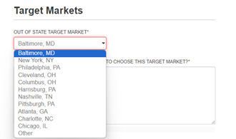and the actual statistics, percentages, and other details in your response.*

**Choose one out-of-state and one in-state target market from the drop-down box and explain why you chose this target market.**

**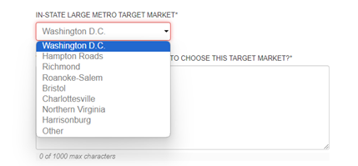***Your choices should be reflected in your marketing plan in the next section.*

**Select one of the three audience characteristics from the drop-down box.**

**What are the additional demographic characteristics of your target audience?**

**What research/data did you use to identify these additional demographic characteristics?**

**Click “Continue to go to Marketing Plans”**

**Marketing & Production Plans Section:**

**This section is worth 50 points.**

*In this section you will fill out two marketing plans and two production plans. The first one in each section is your match. This can be in-kind or cash match. Cash match should be listed as the actual cost of the advertising or eligible production costs you are paying for with your own marketing and event production budget.*

*In-kind marketing match based on owned and earned media can be calculated based on the following:*

* *Print editorial $250/quarter page. $1,000 per full page.* *(Must have appeared in print after June 1, 2024)*
* *Online editorial $500/quarter page. $2,000 per full page. (Must still be hosted online.)*
* *Print listing $100/each (Must have appeared in print after June 1, 2024.)*
* *Online listing $200/each (Must still be hosted online.)*
* *Social Media Followers 10 cents each*
* *Owned media website clicks 10 cents each per link (Must be as of June 1, 2023.)*

*In-kind marketing match should be listed in the In-Kind and Cash Match Marketing Plan as separate line items with detailed information about the articles, dates, social media channel, website, links, etc.*

*You may use up to 10 lines to list your cash or in-kind match.*

*In-Kind production items can be eligible production items that are being discounted or provided at no charge to your organization. Please use the actual estimated value of any in-kind production costs. For cash match production items, please list the estimated amount you will be paying for these eligible production items. The following are allowable in-kind or cash match production expenses.*

* **Cost of temporary stage rentals**
* **Cost of rental of event space or parking lots**
* **Cost of temporary fence rentals**
* **Cost of tent rentals**
* **Cost of table/chair rentals**
* **Cost of porta potty restroom rentals if they are contracted and invoiced.**
* **Audio/Video services, sound engineering, and lighting services that are contracted and invoiced.**
  + - **A/V equipment, lighting purchases, and sound equipment purchases ARE NOT eligible.**
* **Performer booking fees that are contracted and invoiced.**

*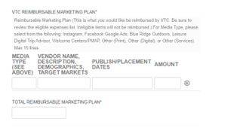In the reimbursable marketing and production plan section, you will list the items for which you will seek reimbursement from VTC.*

*You may use up to ten lines to create your marketing plan.*

***Remember, only eligible items will qualify as cash/in-kind match and/or reimbursement****. Including ineligible items may disqualify your application from being reviewed. Please refer to the full program terms and conditions and/or the eligible items list for his program for a detailed list of which marketing expenses are eligible in this program.*

**Bonus Points Section:**

**Earn up to 5 extra points**

*Going above and beyond the requirement to use the Virginia is for Lovers brand/logo in your marketing can earn you extra points. Choose items from the drop down box and give a detailed description on how you will activate the brand and partner with VTC.*