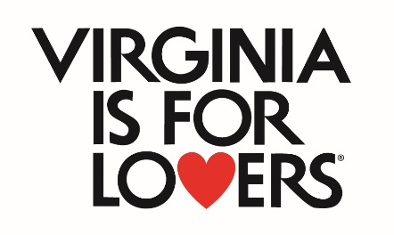

**VTC VA250 Marketing Program**

**Final Report Instructions**

All VTC VA250 Marketing programs should be completed within 18 months of the award notification date. VTC is required to report on the effectiveness of the VTC VA250 Marketing Program to our stakeholders. VTC must show a return on investment of the program.

To that end, you are required to provide a brief final report on the effectiveness and outcomes of your programs. A final report must be submitted to the VTC, either with your final reimbursement request, or within 60 days of the completion of the program. Failure to provide the final report, or failure to meet guidelines stated in the application, may result in being in default and any funding awarded to date may be refundable to VTC.

The final report is a simple, two-page narrative summary of the results of the outcomes of your program, along with a recap of your projected Performance Outcomes with actual outcomes. This should reflect and validate the Performance Outcomes you identified in your original application.

You may also include supporting materials such as screen shots, brochures, videos, etc. Such materials should be sent via USPS or another courier. **Photos and videos should be sent on a USB drive formatted for Windows.**

You may e-mail your Final Report and supporting materials to VTCMLPGrant@virginia.org. However, **DO NOT** **include links to supporting materials in your Final Report.** Attachments (JPG, PDF, etc.) to your Final Report email are allowed. However, please limit the number of attachments and use a USB Drive for large files.

If you have hard copies of Final Report materials, you may return them via USPS or another courier to:

VTC Grants Team  
901 East Cary Street; Suite 900  
Richmond, VA 23219

For questions on final reports and reimbursements, please contact:  
nsaddeen@virginia.org

**VTC VA250 Marketing Final Report**

|  |  |
| --- | --- |
| **Application Number** |  |
| **Program Name** |  |
| **Lead Partner** |  |

**SECTION ONE**

Provide up to two pages of narrative summarizing the outcomes of your program. Provide details on the engagement of your partners in your Hub & Spoke, the effectiveness of your marketing program, and provide explanations on the results as measured by your Performance Outcomes.

**SECTION TWO**

Below is the format for Performance Outcome Results Reporting. Add the relevant performance outcomes identified in your original application included the projections from your application and your actual outcomes from this marketing campaign.

|  |  |  |
| --- | --- | --- |
| **PERFORMANCE OUTCOME** | **What were your numbers when you submitted your application?**  **(PROJECTED OUTCOMES)** | **What are your numbers today?**  **(ACTUAL OUTCOMES)** |
|  |  |  |
|  |  |  |
|  |  |  |
|  |  |  |

**SECTION THREE**

Provide a brief recap of how you activated the Virginia is for Lovers logo as part of your application. Refer to your original application’s Bonus section.