**Virginia Tourism Corporation**

**Microbusiness Marketing Leverage Program Instructions**

**Application must be submitted in VTC’s online application portal.**

**Program Opens: July 16, 2024, at 9 a.m.**

**Program Closes: August 22, 2024, at 5 p.m.**

**(No Late Applications Accepted)**

Please note that the application has changed from the 2023 grant round.

**Award tiers:** $5,000 for tourism-oriented small businesses with fewer than 20 full-time employees. (Part-time, seasonal, and itinerant employees do not count towards this cap.)

$10,000 for DMOs, Main Streets, Chambers and other organizations that engage is tourism marketing to support small tourism-oriented businesses.

**# of proposals to be funded**: approximately 60

**Award notification date:** Early October 2024

**Purpose:** The program is for new initiatives or the expansion of existing marketing initiatives and should be focused on driving out-of-region (at least 50 miles away) and out-of-state visitation from September 2024 to May 2025 to grow Virginia’s off-season visitor revenue, overnight stays, and to support small tourism-oriented businesses in the off-season.

**Applicant Acknowledgment Section:**

*Applicants must check the boxes acknowledging they understand the programs rules, terms, and conditions*.

*Please be sure that the checkmarks turn blue as you check them off in the online application portal.*

*Once you complete the checkbox acknowledgements, click “Continue to Program Information” to continue to the next section.*

**Program & Contact Information Section:**

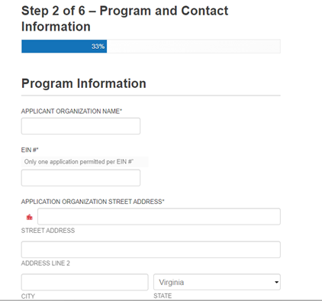**Applicant Organization Name:**

**EIN#/SSN:** *Please do not use an SSN if you have an EIN. SSN is only allowable for sole proprietorships without an EIN.*

**Applicant Street Address:**

**City, State, Zip:**

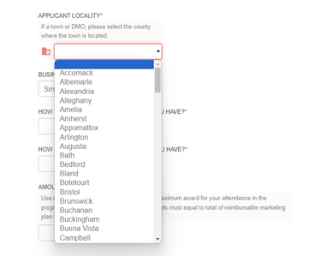

**Select Applicant Locality from the drop-down list. If a town, select the county.**

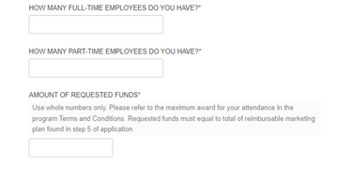

**How many full-time employees do you have:**

**How many part-time employees do you have:**

*\*\*This program is only open to applicants with less than 20 full-time employees. \*\**

**Amount of Requested Funds:**

*The amount of requested funds needs to be equal or less than your match total and needs to be equal to your reimbursable marketing plan total.*

**Applicant Contact Information Section:**

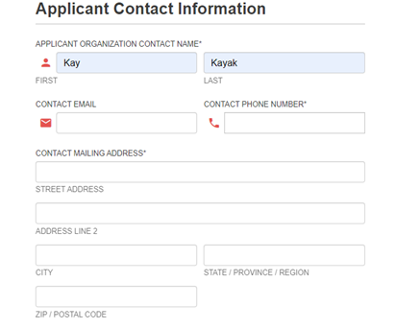**Applicant Contact Name:**

**Email:**

**Phone:**

**Address:**

**City, State, Zip:**

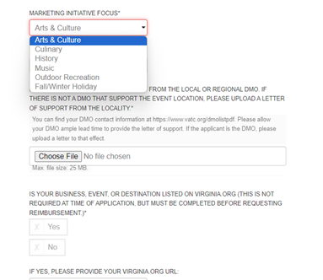

**Choose the focus of your proposal/application from the drop-down box.**

**Upload a letter of support from the local or regional DMO.** *You can find a list of DMOs at* [*www.vatc.org/dmolist*](http://www.vatc.org/dmolist)*. If there is no DMO covering your locality, you may upload a letter of support from a locality leader such as town manager, county manager, county supervisor, etc.*

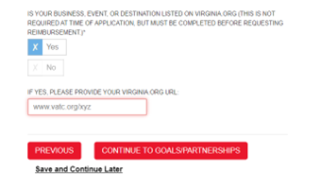**Indicate whether your event/business/destination is listed on Virginia.org** and **include the URL where requested**. *While the listing is not required to apply, you must have your listing completed before you seek reimbursement.*

*You can create an account and listing here:* [*https://www.vatc.org/marketing/digital-marketing/webmarketing/*](https://www.vatc.org/marketing/digital-marketing/webmarketing/)

*This is a multi-step process and can not be completed in one day.*

**Click “Continue to Goals and Partnerships”**

**Goals & Partnerships Section:**

**This section is worth 25 points.**

**What do you want to accomplish with your requested funds:**

*Think through your goals for this funding. Be clear, concise, and succinct. Do you want to bring in more visitors from North Carolina, do you want to target more holiday shoppers from Philadelphia or Delaware, do you want to create fall mountain getaway weekend packages and target mid-Atlantic coastal states?*

**How will you measure your progress?**

*Tell us how you will measure your progress toward your goals and in the next section select two Performance Outcomes that align with your goals and ability to track data.*

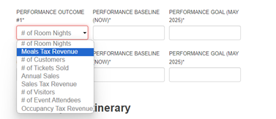**Select two performance outcomes that you can track and that align with your program goals.** *Give a baseline number as of the date of application and then give a goal you will strive to achieve by May 2025.*

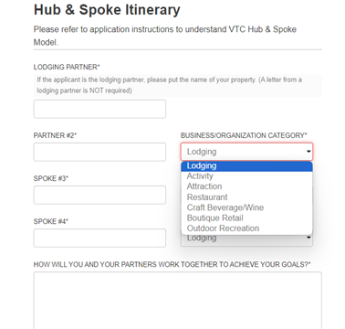

**The Hub and Spoke is VTC’s itinerary building tool and are designed to help you build tourism partnerships in your destination.** *Imagine your business, destination, or attraction as the hub. And then identify a lodging partner, another tourism partner, and two tourism-oriented spokes that will work with you to achieve your goals.*

**Be sure to use the drop-down box and identify the tourism category of your partners and spokes.** *One lodging partner is required. However, you may select additional lodging partners. You do not need a letter of support from a lodging partner in this program.*

**How will you and your partners work together to achieve your goals?**

*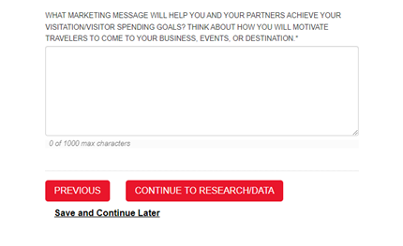In this section, tell us how you are all working together. Are you creating lodging packages, cross-promoting each other, pooling marketing funds to do more robust marketing, etc.*

**What marketing message will help you achieve your visitation goals? How will you motivate travelers to visit?**

*Think through what message, images, videos, taglines, etc. will motivate your target market/demographic to visit your business, destination, or attraction. How will you convert a prospective visitor into one that makes a lodging reservation and visits your destination/business/attraction?*

**Click “Continue to the Research/Data Section”**

**Research & Data Section:**

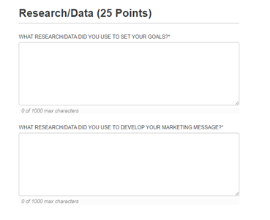**This section is worth 25 points.**

**What research did you use to set your goals?**

**What research did you use to develop your marketing message?**

*In this section, indicate what research you data-mined to make your marketing decisions. VTC research can be found on* [*www.vatc.org/research*](http://www.vatc.org/research)*. You might also use social media insights, focus group studies, Adara, Zartico, Arrivalist or other paid research vendors or research studies. Please be detailed in your response.*

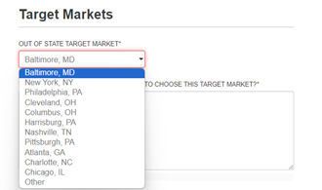

**Choose one out-of-state and one in-state target market from the drop-down box and explain why you chose this target market.**

*Your choices should be reflected in your marketing plan in the next section.*

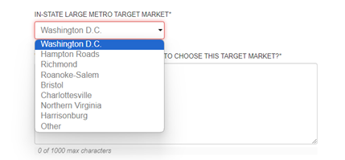

**What are the demographic characteristics of your target audience?**

**What research/data did you use to identify the demographic characteristics?**

**Click “Continue to go to Marketing Plans Section.”**

**Marketing Plans Section:**

**This section is worth 50 points.**

*In this section you will fill out two marketing plans. The first one is your match. This can be in-kind or cash match. Cash match should be listed by line item as the actual cost of the advertising, the vendor, placement dates, target audience etc. you are paying for with your own marketing budget. Please refer to the example application.*

*In-kind marketing match based on owned and earned media can be calculated based on the following:*

* *Print editorial $250/quarter page. $1,000 per full page.* *(Must have appeared in print after June 1, 2024)*
* *Online editorial $500/quarter page. $2,000 per full page. (Must still be hosted online.)*
* *Print listing $100/each (Must have appeared in print after June 1, 2024.)*
* *Online listing $200/each (Must still be hosted online.)*
* *Social Media Followers 10 cents each*
* *Owned media website clicks 10 cents each per link (Must be as of June 1, 2024)*

*In-kind marketing match should be listed in the In-Kind and Cash Match Marketing Plan as separate line items with detailed information about the articles, dates, social media channel, website, links, etc.*

*You may use up to 10 lines to list your cash or in-kind match.*

*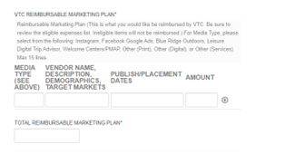In the reimbursable marketing plan section, you will list the items for which you will seek reimbursement from VTC. Please refer to the example application. Be sure the list the vendor, target market demographics, description of the marketing materials, placement dates, and estimated cost.*

*You may use up to ten lines to create your marketing plan.*

*Remember, only eligible items will qualify as cash/in-kind match and/or reimbursement. Including ineligible items may disqualify your application from being reviewed. Please refer to the full program terms and conditions and/or the eligible items list for his program for a detailed list of which marketing expenses are eligible in this program.*

**Bonus Points Section:**

**Earn up to 5 extra points.**

*Going beyond the requirement to use the Virginia is for Lovers brand/logo in your marketing can earn you extra points. Choose items from the drop-down box and give a detailed description on how you will activate the brand and partner with VTC.*

*Selecting VTC Photography or Videography opportunity does not guarantee staff coverage of your program, business, or event. However, we will share these opportunities with the Brand and Marketing teams so they can evaluate their needs and schedules.*